First Name MI Last Name ^{a,*} and First Name MI Last Name ^{b}

ª Affiliation, Country
^{b} Affiliation, Country

Author Guidelines of Proceeding for

The 8th International Symposium on Aero Aqua Bio-Mechanisms

Abstract—Belows are general instructions to guide the preparation of your proceeding manuscript. You may prepare the PDF as well as MS Word files of your manuscript. The proceedings will be uploaded on the web server of the society of of aero aqua bio-mechanisms (ABMECH). Please follow these instructions. Use this document as a template if you are using Microsoft Word. This part is for the abstract. The abstract should be within 100 words.

Index Terms— About four key words or phrases, separated by commas.

INSTRUCTIONS FOR PROCEEDING PREPARATION
  - Length and Style
The length of the proceeding is WITHIN SIX PAGES for all proceedings (including keynote lectures). Use separate sections for abstract, index terms, introduction, methods, results, discussion, conclusions, acknowledgements and references.
- References
Number references in their text order, using square brackets []. Place citations at the end of the text.

Example:
[1] G. Eason, B. Noble, and I.N. Sneddon, “On certain integrals of Lipschitz-Hankel type involving products of Bessel functions,” Phil. Trans. Roy. Soc. London, vol. A247, pp. 529-551, April 1955.
[2] M. Young, The Technical Writer’s Handbook. Mill Valley, CA: University Science, 1989.

- Paper Size and Layout
Use A4 paper (210 mm x 297 mm). We do not accept letter size paper.
Center the title, author names and affiliations. Type the paper in two columns. Each column of the text should be left and right justifies. The footnote should be added at the bottom in the left column of the first page. Please supply corresponding author's address and e-mail address.

* Corresponding author: Address, Zip code, Country, E-mail:.
- Margins
Leave 25 mm (1") margins at the top and bottom, and 18 mm (0.7") on the left and right sides.
- Type Size
Use 14 points Roman characters for the title, 12 points Roman characters for names and affiliations, 10 point Roman characters for the text, 8 points Roman characters for the footnote, and 8 points for the references. Please do not use 2 byte characters (Japanese, Chinese etc.). Please check it by Adobe Acrobat (“File”-> “Property” -> “Font”) before you submit.
- Figures
Number and provide a caption (legend) for each figure; do not use characters smaller than 8 points.
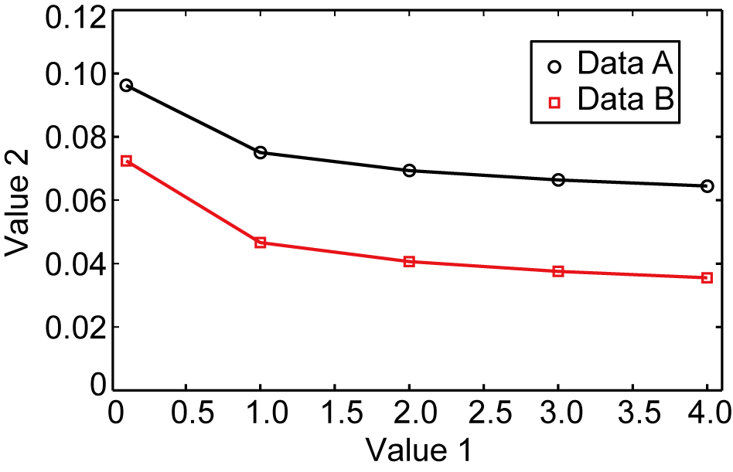
Fig.1 Example figure.

SUBMISSION INSTRUCTIONS
  - Deadline for Manuscripts
The completed PDF or MS Word files are due on the 15th of September, 2022. If you are unable to meet the deadline, please notify conference secretariat, as soon as possible via E-mail: nakai@tottori-u.ac.jp.
B. Submission of Manuscript
Please submit the completed PDF file from the EasyChair login page for ISABMEC 2022, https://easychair.org/my/conference?conf=isabmec2022
Please make sure to rename your file as your paper number. For example, if your paper number is “12”, the filename should be “12.pdf”. The PDF file should be press quality. The size of file is less than 8MB.

